Week Ending: | DAY: |  |  |  | Subject: Mathematics
Duration: 60mins per lesson |  |  |  |  | Strand: Geometry and measurement
Class: B3 | Class Size: |  |  |  | Sub Strand: Data Collection And Organization
Content Standard:  B3.3.3.3 Demonstrate an understanding of time taken by events in days, weeks and months |  |  | Indicator:  B3.4.1.1.1 / B3.4.1.2.1 Gather and record Data using concrete graphs and pictographs to solve problems |  |  | Lesson:  1 OF 1
Performance Indicator:  - Learners can gather and record Data using concrete graphs and pictographs to solve problems |  |  |  | CORE COMPETENCE:  Problem Solving skills; Critical Thinking; Justification of Ideas; Collaborative Learning; Personal
Teaching/ Learning Resources |  | Ruler, rope, meter rule
References: Mathematics Curriculum Pg. 73
DAYS | PHASE 1: STARTER | PHASE 2: MAIN | PHASE 3: REFLECTION
Monday | Have learners play games and recite familiar rhymes to begin the lesson  Using questions and answers, review their understanding of the previous lesson | Guide learners to use tallies, checkmarks, charts, lists or tables to collect and organize data to answer a question.  Example: call ten students to the front of the class and sort them into groups; that is group of boys and group of girls.  Let learners identify the number of boys and girls in each group.  Have learners to use tallies to represent the number of boys and girls on a table. | Give learners task to complete whiles you go round to guide those who don’t understand.  Give remedial learning to those who may need special help.
Tuesday | Have learners play games and recite familiar rhymes to begin the lesson  Using questions and answers, review their understanding of the previous lesson | Guide learners to use tallies, checkmarks, charts, lists or tables to answer questions, and justify the answers, based on the organized data.  Have learners to answer questions based on the data collected on the number of boys and girls.  Example: i. How many boys?  ii. how many girls?  iii. how many altogether?  iv. more girls than boys. Yes/No  v. less boys than girls? Yes/No | Give learners task to complete whiles you go round to guide those who don’t understand.  Give remedial learning to those who may need special help.
Wednesday | Have learners play games and recite familiar rhymes to begin the lesson  Using questions and answers, review their understanding of the previous lesson | Let gather and bring all items that can found in the classroom.  Example: pencils, sharpeners, erasers, crayons, bags, dusters, chalk, pens, etc.  Let them sort and group them. That is group of pencils, group of pens, etc.  Learners to count and identify the number of items in each group.  Have learners to use tallies to represent the number of boys and girls on a table and answer questions based on the data collected. | Give learners task to complete whiles you go round to guide those who don’t understand.  Give remedial learning to those who may need special help.
Thursday | Have learners play games and recite familiar rhymes to begin the lesson  Using questions and answers, review their understanding of the previous lesson | Let learners Identify common features of bar graphs that use one-to-many correspondence and use that understanding to create concrete graphs or pictographs, complete with title, labeled axes, key or legend, to represent data collected (up to 3 categories of data)  Draw a bar graph on the board depicting the food learners like best  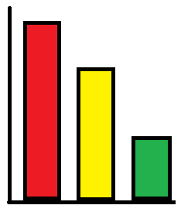  FUFU  BANKU  R  I  C  E  &  S  T  EW  Learners to use the graph to answer and/or pose questions, and justify the answers, based on the organized data  e.g. “What is the class favorite food? | Give learners task to complete whiles you go round to guide those who don’t understand.  Give remedial learning to those who may need special help.
Friday | Have learners play games and recite familiar rhymes to begin the lesson  Using questions and answers, review their understanding of the previous lesson | Let learners use a one-to-many correspondence solve simple problems (how many altogether, comparing, or take apart problems) requiring interpretation of one-to many bar graphs (up to 3 categories of data)  Draw a bar graph on the board depicting learners favorite colors  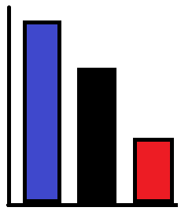  BLUE  BLACK  RED  Learners to use the graph to answer and/or pose questions, and justify the answers, based on the organized data  e.g. “What is the class favorite color? | Give learners task to complete whiles you go round to guide those who don’t understand.  Give remedial learning to those who may need special help.

